Enoch Nana Tabi Oduro
FCM.41.018.197.23
CY3B
Relevance tree for Climate Change - four levels deep, from the root down through causes, effects, and responses to specific leaf-level concepts.
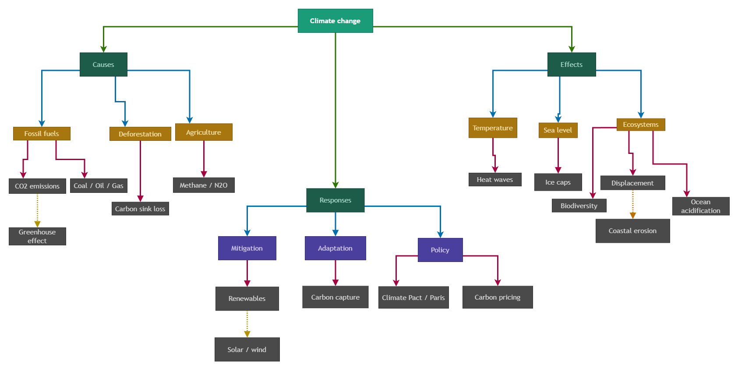
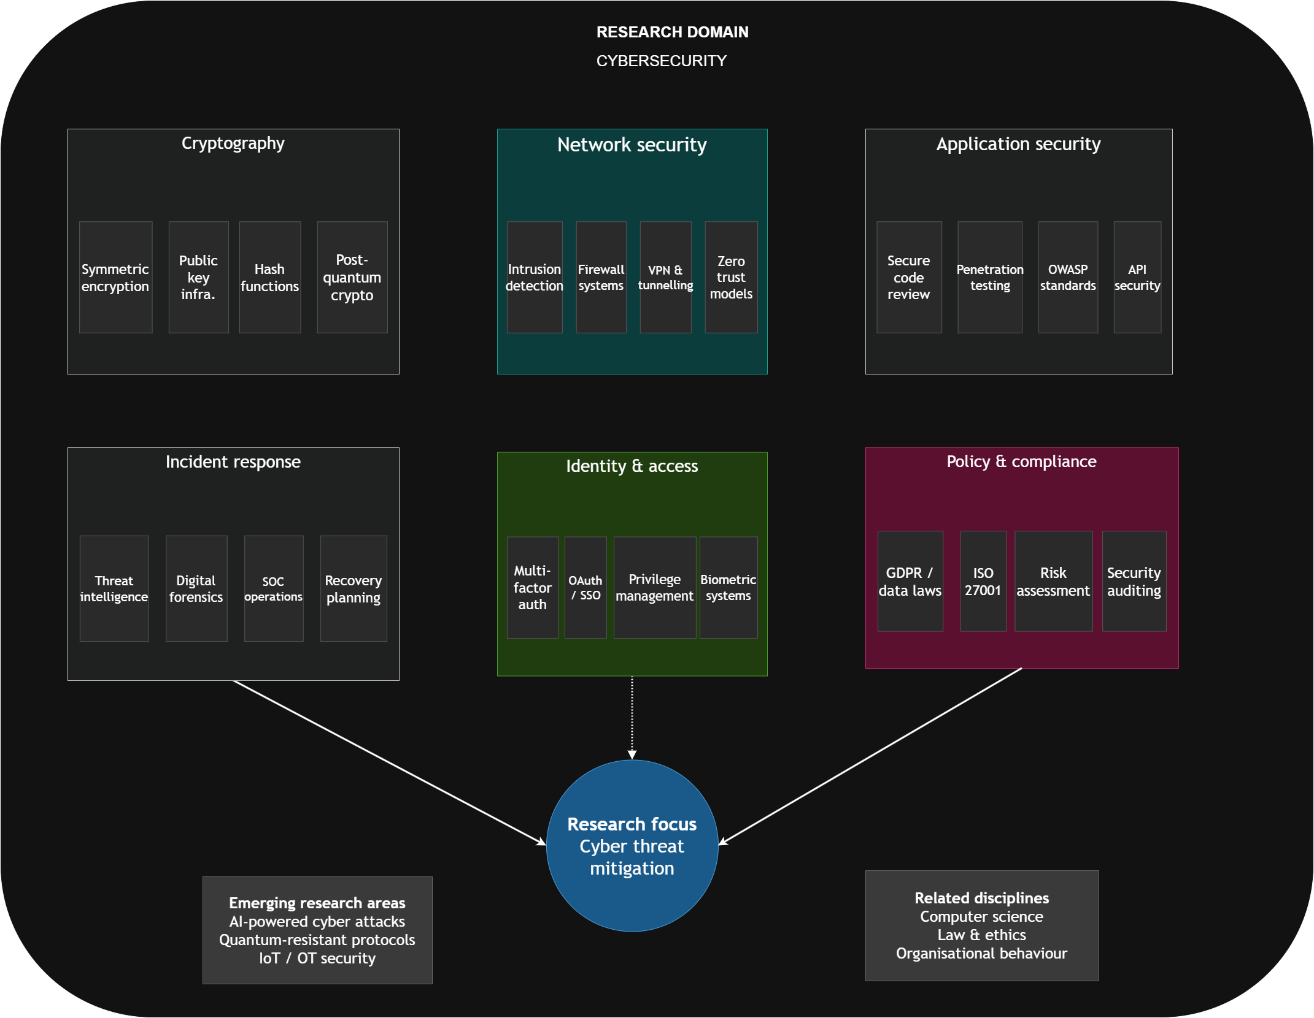
Territory map for Cybersecurity, with six sub-domains (network security, application security, cryptography, incident response, identity & access, and policy & compliance) all feeding into a central research focus.
Jgghh